ESTIMATION OF BUSINESS EXPENSES

INTRODUCTION:

* Estimating business expenses is an important step in determining how much money you need to start and keep your business running without encountering cash flow problems.
* Every business has different requirements,depending on the type of products or service it sells,the size of the company and the stage of the growth of the business.
* The type of space in which you set up your business needs to be estimated as an ongoing expense.
* Estimate the costs of getting people to buy your company’s offering,including design of your logo,business cards,websites and a brochure or flyer that outlines your products or services.

PURPOSE:

* Estimates are documents that provides approximate costs for project.
* Small businesses create them for potential clients so both parties are clear on the ins and outs of a project before it starts.
* Fresh books has an estimates feature that help you build an estimate quickly and easily.

PROBLEM DESTINATION AND DESIGN THINKING:

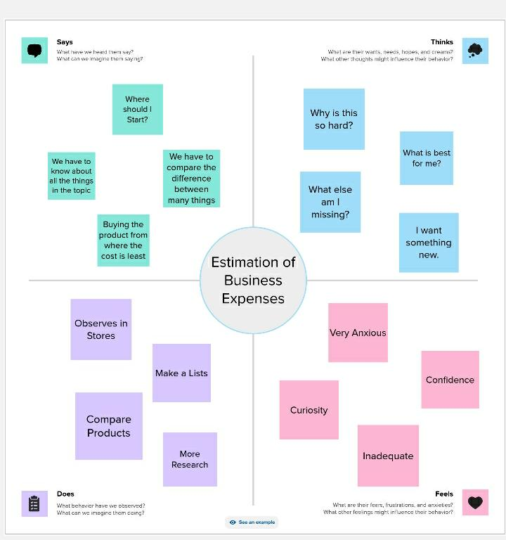

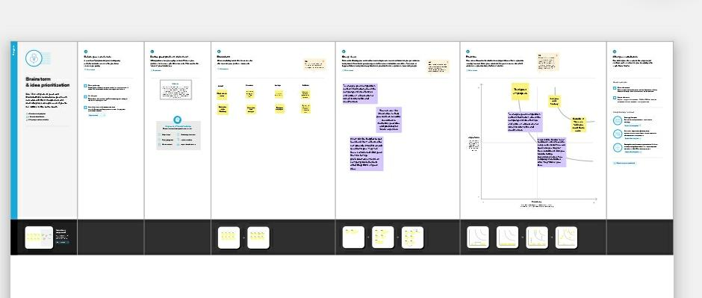

RESULT: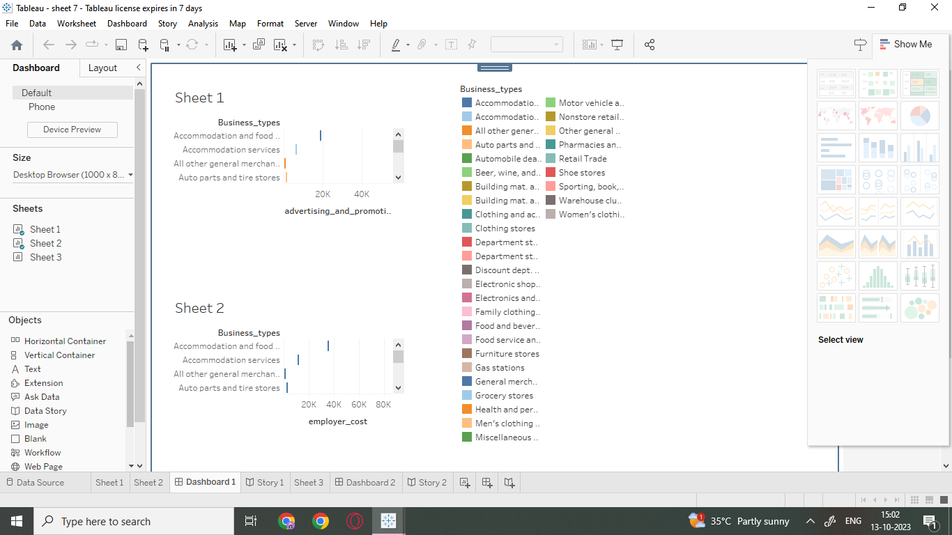

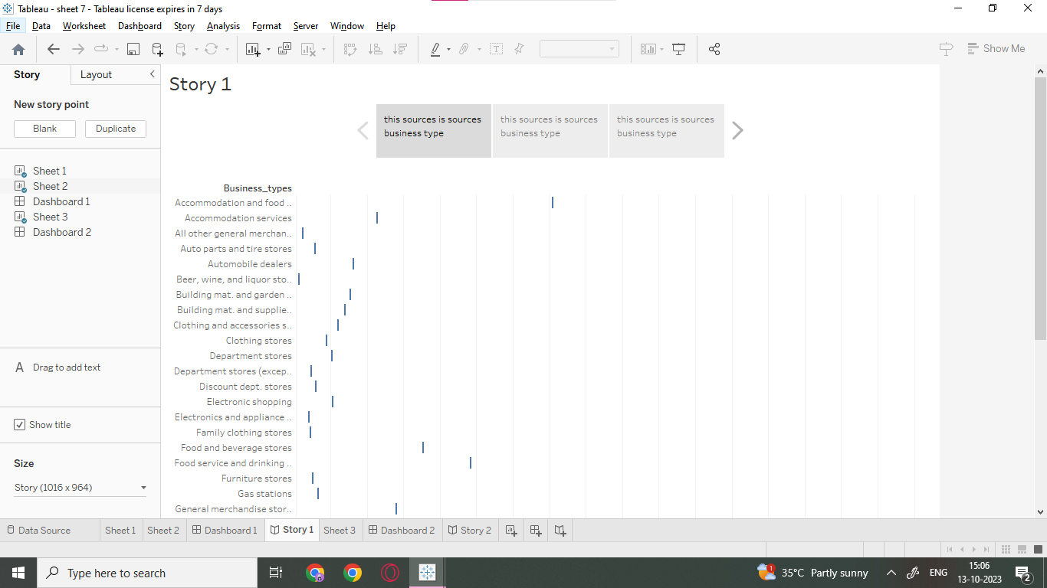

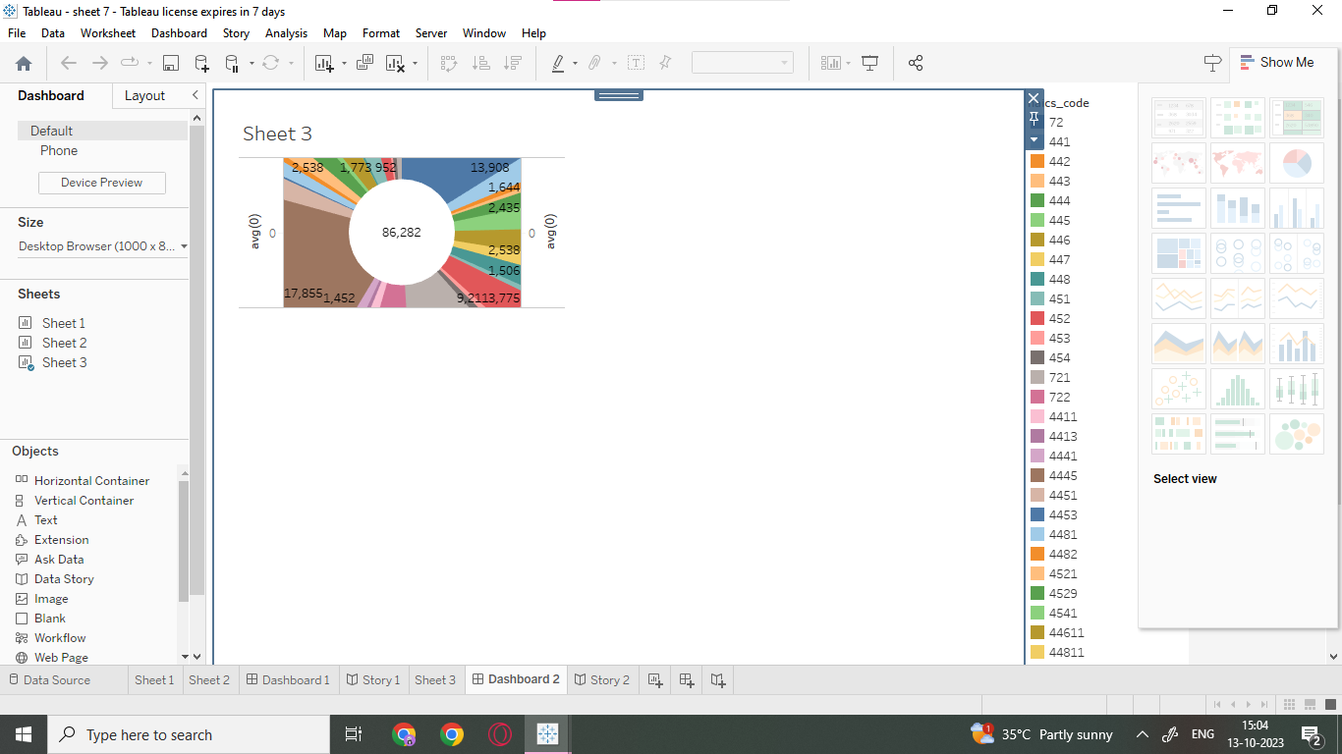

ADVANTAGES:

* Greater knowledge of business performance and growth.
* Insight into company resale value.
* A better understanding of company assets.
* Determining employee benefits and retention plans.

DISADVANTAGES:

* It is difficult to estimate the depreciation of properties that are older.
* Expenditure occurred between processes are difficult to prevent.
* The costing records only indicate previous performance, but management makes long term decisions.

APPLICATIONS:

* Insurances
* Maintenance and Repairs
* Advertising
* Bank Fees
* Employee benefits
* Home office expenses
* Interest paid

CONCLUSION:

* It is very useful for us to learn new things in Business.
* We all learned how to estimate in business expenses through this team work.

FUTURE SCOPE:

* Business always has scope in future ,only if one is serious about it and aim to prosper and not thrive.
* People often falter in business , because they deem it to be an easy task and looks for success very early on.
* Business can be a real good scope for future,but one needs to be

very calculative in its decisions and accurate in future prospects.

APPENDIX:

The business plan appendix may include documents such as resumes of key team members,market research data,financial statement ,legal agreements, permits and licences, products or service brochures, and any additional supporting documents relevant to the business.